# Women in Tech Game

🎮️ Name of the game:

👥 Stakeholders:

* Dev:Jami Schwarzwalder, [@Name](https://help.nuclino.com/988f802d-mention-a-team-member)
* Design: [@Name](https://help.nuclino.com/988f802d-mention-a-team-member), [@Name](https://help.nuclino.com/988f802d-mention-a-team-member)
* QA: [@Name](https://help.nuclino.com/988f802d-mention-a-team-member)

# Overview

## 📐 Project scope

* Budget:
* Timeline:

## 🗣️ Elevator Pitch

*One sentence briefly but concisely describing the game.*

Experience the first year in the life of a female software developer

## 💵 Monetization

*Briefly explain how/if you plan to monetize the game.*

# Story

*A one-paragraph synopsis of the story. If the story is too long, save the details for a separate document.*

[Name] is hired as a developer at a Startup, she works on an Agile team and makes choices about how to spend her day after each standup. Decisions affect Team Productivity and Personal Productivity.

# Gameplay

*Describe how the game is played. Be specific and describe each feature in a structured way.*

## Core Game Mechanic #1

* Details: Choose what action to take after reading narrative
* How it works: Presented with at least 2 choices as text. Player must select one and it will affect Team Productivity and Personal Productivity

## Core Game Mechanic #2

* Details: Some Narratives impact future Choices
* How it works: Options might unlock days, or add a bonus to a future day if/when encountered

## Core Game Mechanic #3

* Details: Narrative of the day and Choices is read out to the player
* How it works: When a new day starts, the Narrative description is read aloud to the player, as are the choices.

# Game elements

*Describe your game world, including all the characters, location, object, and other* elements in it.

Text Box with description of days choice

Button or link associated with each choice

Progress bar for Team’s Productivity that changes based on the Player’s choice

Progress bar for Personal Productivity that changes based on the Player’s choice

Possibly use Font Awesome Icons for the Progress Bars

Brackey’s Tutorial on build Quest System - <https://www.youtube.com/watch?v=e7VEe_qW4oE>

artbreeder for Avatars <https://www.artbreeder.com/>

## 👤 Characters

* Main Character - Female Software Developer with no prior professional experience
* CoWorker - Male Software Developer started on the same day as Main Character.
* CoWorker - Male Software Developer 1 year experience on team. Assigned Onboarding Buddy
* CoWorker - Male Software Developer 2 years experience on the team,
* CoWorker - Team Lead 4 years experience. Made the system, Not good at explaining how the system works. Most often gives advice to read the code. Doesn’t like writing Documentation or Wikis
* CoWorker - Male Software Developer 1 year experience
* UX Designer - Female New in Role
* Manager - Male Newly promoted from Engineer
* Project Manager - Female 4 years in role, works with 5 teams
* New Hire - Male Software Developer with 0 prior experience
* New Hire - Female Software Developer with 0 year prior experience
* Intern - Male College Student with 1 year of school left

## 🗺️ Locations - Just Described

* … In the Office Open Office Layout
* … Working from Home
* … Kitchen
* … Conference Room
* …

## 🏆️ Levels / missions

* … Based on Glue Work <https://www.slideshare.net/TanyaReilly/being-glue>
* … Interview Intern
* … Mentor Intern
* … Interview New Hire/College Grad
* … Mentor
* … Migrate from Python 2.7 to 3.6
* … Code Reviews
* … Find someone to review your CR
* … Spend time to add tests to the System
* … Happy Hours
* … Lunch Stolen
* …

## 📦️ Objects

* ......
* ...

# Assets

*Here is where you will include all of the assets needed as well as brief descriptions.*

## 🎨 Art

* … Inspired by Reigns - <https://store.steampowered.com/app/474750/Reigns/>
* … Possibly use Font Awesome Icons for the Progress Bars
* … Background ?
* … Avatar for talking to each member of Team from Art breeder [Artbreeder](https://www.artbreeder.com/)
* 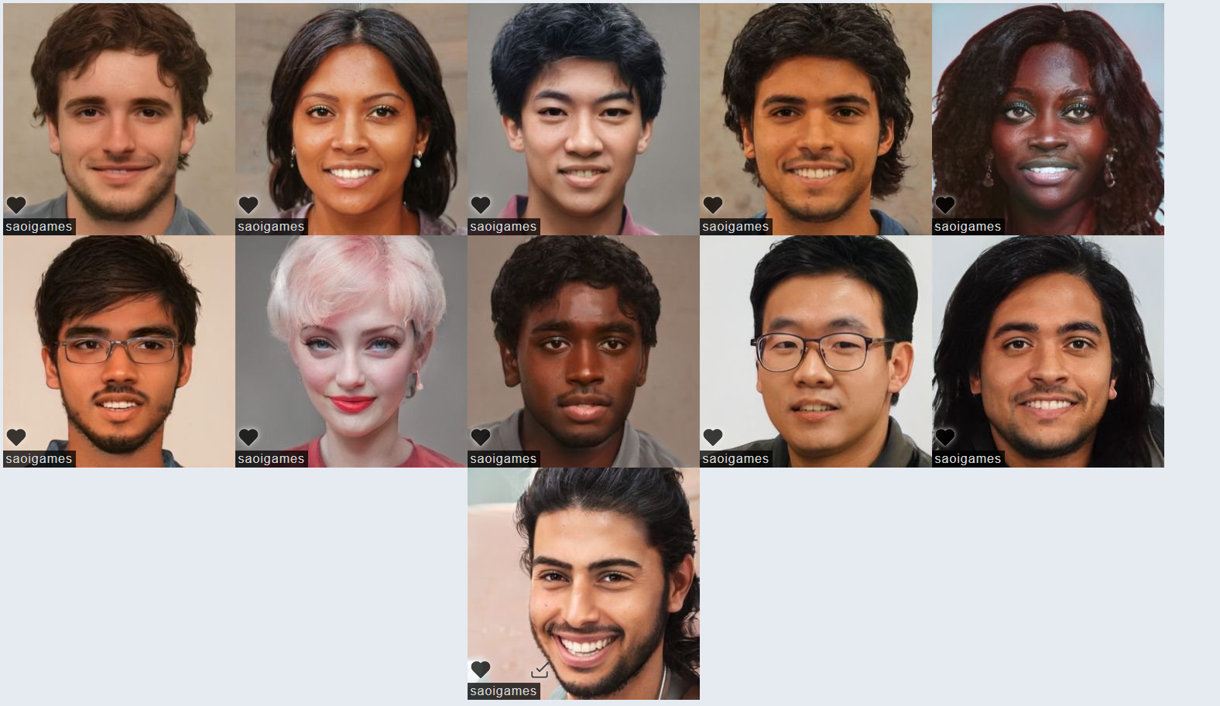

## 🔊 Sound

* ...
* ...
* ...

## 🏃‍ Animation

* ...
* ...
* ...